**AHMED HAMED ALY**

18308279

DATE: 9/NOV/2018

LAB: LG35/36

TIME: 4PM TO 6PM

**Introduction**

The experiment consisted of five main parts,

(A) Connecting a circuit using the circuit diagram provided in the question.

(B) Make a superimposed plot of the input and output when you apply a sine wave input of 10Khz.

(C) Plot (on a graph) the gain vs the frequency.

(D) Interchanging the resistor and the capacitor and steps (B) and (C).

(E) Suggest applications for the circuits which are simple low and high pass filters.

There was a couple of factors I had to consider before starting the experiment. These included,

Using working apparatus that has been tested before and won’t cause an error in my result;

Calibrated the oscilloscope using the probes and making sure that line was aligned with the middle;

Understanding what a capacitor is and how it functioned in comparison to the rest of the circuit. A capacitor is a device used to store electric charge (shown below).

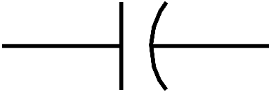

Capacitor

**Objective**

The objective of the experiment is to create 2 circuits that acts as a low pass filter and a high pass filter.

What I expected to see in the graph for the **low-pass filter** is: 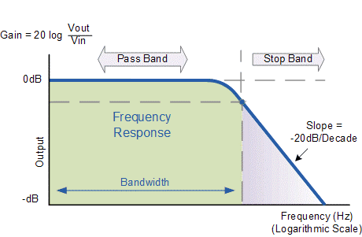

I expect to see that graph because the filter should pass signals with a frequency lower than the cut-off frequency and attenuates signals with a frequency that is higher than the cut-off frequency.

What I expected to see in the graph for the **high-pass filter** is: 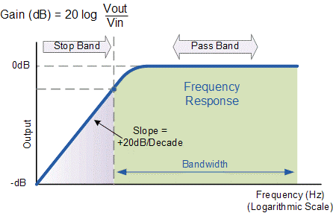

I expect to that graph because the filter should pass signals with a frequency higher than the cut-off frequency and attenuates signals with a frequency that is lower than the cut-off frequency.

**Apparatus**

The apparatus used for the experiment (shown below) were vital to producing the results I acquired from the experiment.

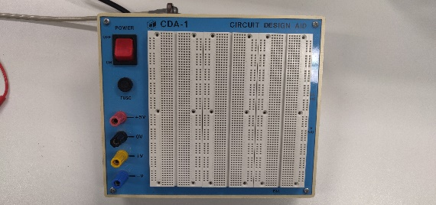 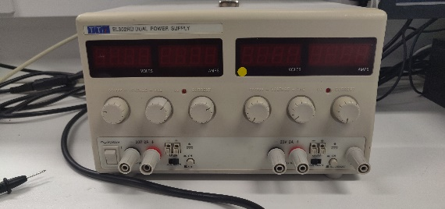

Breadboard Power Supply

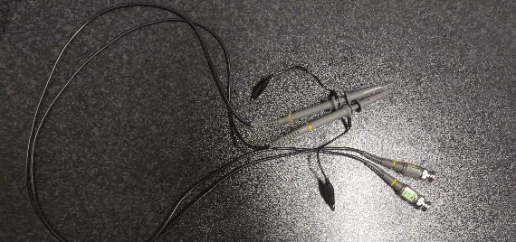 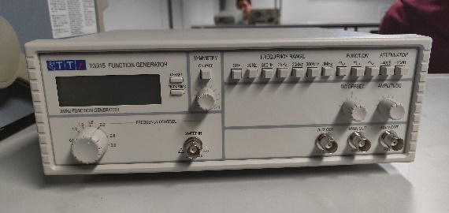

Probes ` Function Generator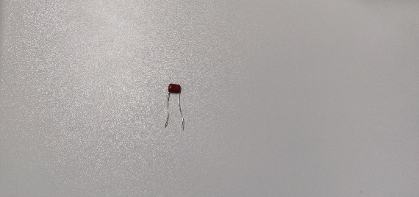 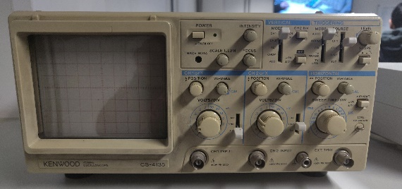

22nF Capacitor Oscilloscope

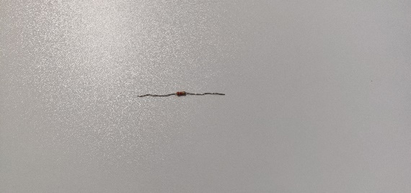

2.2KΩ Resistor

**Method**

1. Connect the circuit (**CIRCUIT 1**) in the diagram shown below.

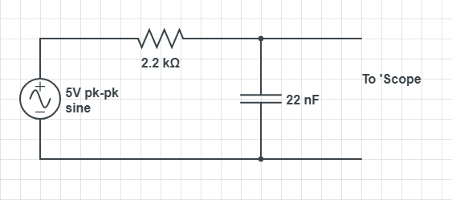

1. I created a superimposed plot of the input and output at 10Khz.
2. I set the frequency to 100hz then recorded the output voltage and repeated until I reached 20Khz and went up in intervals of 1Khz.
3. I plotted the graph, Gain vs Log (Frequency). I got the gain by using the formula (20*log (Vout /Vin)
4. Connect the circuit (**CIRCUIT 2**) in the diagram show below by switching the capacitor and the resistor around.

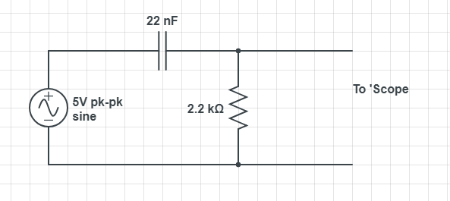

1. I repeated steps 3 and 4 for circuit 2.

**Data/Graph**

**High-Pass Filter**

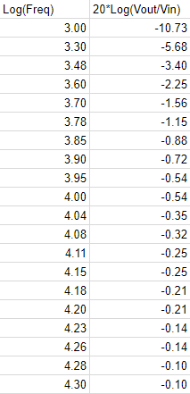 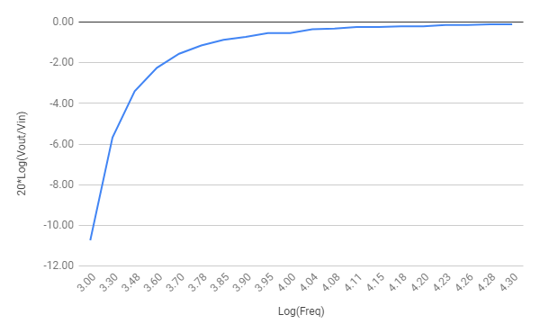

**Low-Pass Filter**

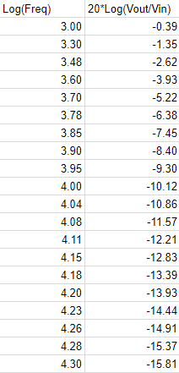 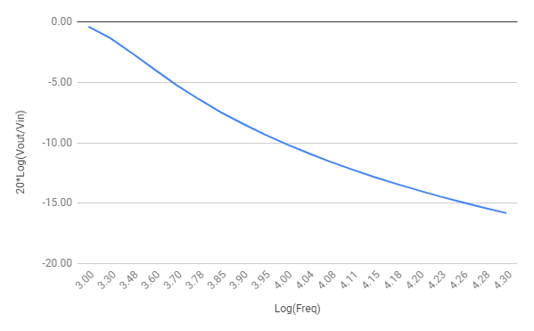

**Data Analysis**

From my results, I noticed the sort of graph you should expect from a low pass and high pass filter. Circuit 1 is a low pass filter which is a device that passes signals with frequencies that are lower than the cut-off signals above the cut-off frequency while circuit 2 is a high pass filter which is a device that reduces the signal below the cut-off frequency and instead transfers signals with higher frequencies

In relation to the circuit the capacitor is a reactive device. This means when the frequency is low, it returns a high resistance and when the frequency is high it returns a low resistance. This means it will block out the DC signals from entering and passing to another part of the circuit, in other words, it “filters out” unwanted signals so it allows an ideal signal to pass through. In circuit 2 the capacitor is high and doesn’t allow any input signal until it reaches the cut-off frequency. When the cut-off frequency is reached the capacitor acts as a short circuit and allows all the input signal to pass to the out output.

From my graph, it didn’t match what I expected. I expected a graph that eventually flattened out but due to the nature of the question which stated to only take reading for the frequency from 1000hz to 20000hz, the graph didn’t flatten out. However, if I was to extend the frequency to perhaps 30000hz, I would expect to notice the graphs flattening out.

There aren’t many **uses** for high and low pass filters in the real world.

Some of the main applications for a high-pass filter is: 1. Used in loud speakers to reduce the low-level noise; 2. Used in equalizers; 3. Used in audio amplifiers to amplify the higher frequency signals.

Some of the main applications for a low-pass filter is: 1. Used to filter noise from a circuit; 2. Used as an equalizer in audio applications; 3. Used in receivers for efficient reception of the baseband signal.

**Conclusion**

In conclusion, the above data and analysis show that the circuits above are a simple low and high pass filter. Such a circuit can be used for many different devices as outlined above which make these circuits very useful for everyday applications.

**References**

<https://www.scribd.com/doc/12936752/Physics-222-Ohm-s-Law-Lab-Report>

<https://www.circuitlab.com/>

https://electronicsclub.info/circuitsymbols.htm

<https://www.quora.com/What-is-meant-by-low-pass-and-high-pass-filters>

<https://www.electronics-tutorials.ws/filter/filter_3.html>

<https://www.electronics-tutorials.ws/filter/filter_2.html>

<https://nanohub.org/resources/14905/download/LOW_PASS_FILTERS.pdf>

https://www.quora.com/What-are-the-applications-of-high-pass-filters-in-the-real-world